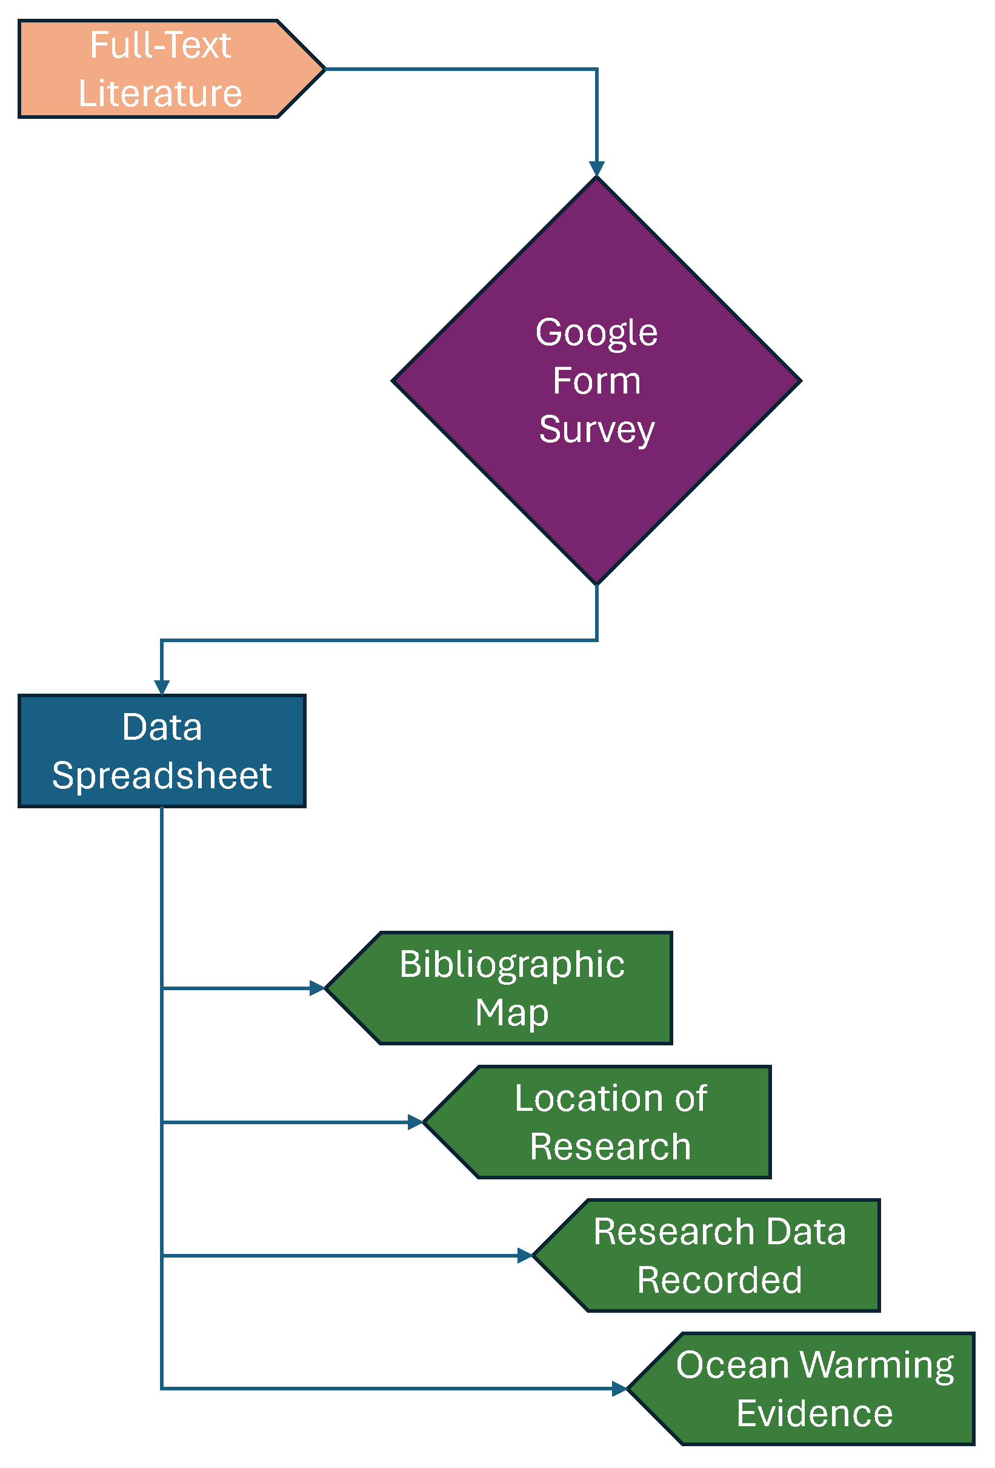
Figure 2 The data mapping methods flow chart for this systematic map.

